|  |
| --- |
| Information System  Analysis and Modeling  La Salle College (420SA2AS)  Clinic Project  Start Up Plan |
| **Sik Lam MO(1317843)**  **Kamil Obiedzinski(2211219)**  **Hyemi Park(2212025)**  **Manasa Manohara Shetty(2212113)**  Contents  COMPANY OVERVIEW 5  Our Team 5  Company Mission 5  Clinic Santé .co 5  BUSINESS DESCRIPTION 6  Pitch 6  Product and Scope 6  Markets Analysis 6  Long-term Future Prospect 7  FINANCIAL PLAN 8  Budget 8  SALES PLAN 8  START-UP COST 9  LOCATION/OFFICE 9  Online Services 9  LABOR EXPENSES 9  PROJECT PROFIT FORECASTING 10  THE PRODUCT VISION 11  PRODUCT PERSONAS 12  UML 17  Use Case 17  Online Booking 17  Login 18  Online Pay 18  Online Scheduling 18  Sequence Diagram 19  Confirm Appointment 19  Select Open Time Slot 20  Select Clinic 20  Search 21  Search Today 21  Search Language 21  Search Specialist 22  Search Nearby 22  Patient Login 23  Register 23  Cancel Appointment 24  Password Reset 24  Make Payment 25  Credit Payment 25  Payment subscription 26  Clinic Login 26  Manage Appointment 27  Cancel Appointment 27  Add Appointment 28  Modify Appointment 28  Class Diagram 29  PRODUCT ROADMAP 30  KANBAN BOARD 32  Sprint 1 32  Sprint 2 33  Sprint 3 33  Sprint 4 34  Sprint 5 34  Sprint 6 34  MOCK-UP 35  PROJECT APPENDIX 37  Team Charter 37  SWOT Analysis 38  Communication Plan 38  Roles & Responsibilities 38  Team Charter 39  Meeting Logs 40  Retrospective 58 |

# COMPANY OVERVIEW

## Our Team

We are four programmer-analysts that are prepared and willing to solve the inefficiencies associated with outdated and obsolete systems caused by sunk costs into legacy dependencies.

Sik Lam Mo, Manasa Manohara Shetty, Hyemi Park, Kamil Obiedzinski

## Company Mission

Our purpose is to make applications that have genuine impacts on companies that adopt and implement our software. We believe that companies are hindering their development and growth when they neglect to modernize as technologies advance.

## Clinic Santé .co

We work for the independent software team “Clinic Santé Co.”. Clinic Santé Co. design and build time management software to help those who oversee and maintain appointments of clinics that need to manage daily patients list, distribute information across different groups, and handle appointment coordination. The easier it is to make and manage appointments, the more people will be able to heal and get the treatment that they need.

# BUSINESS DESCRIPTION

## Pitch

Our company, Clinic Sante, is developing a network of clinic scheduling applications to help patients make appointments at clinics with outdated systems by modernizing and connecting the front end of different clinics. We compete in the growing privately owned clinic market which is projected to be valued at over 10.8 Billion USD by 2030. Our product is similar to cliniquemedicale1851 and cliniqueenroute, but our product is not designed for a single clinic but a network of clinics which allows searchability and a more accurate estimate of wait times.

## Product and Scope

We are pitching an appointment scheduling application for clinics. The fundamental purpose of the application is to allow patients to make appointments online at nearby clinics in a fast, reliable, and convenient manner, while at the same time facilitating the workflow of the administrative clerks at clinics. Our scope focuses on the administrative medical field because the medical system cannot improve if the front-end portion is an obstacle. We are limiting our scope to the province of Quebec on account of the laws and the differentiating factors in medical care by province.

## Markets Analysis

Our product is targeting two markets. Our primary market is the existing privately owned medium-sized clinics that have outdated and obsolete online appointment systems. These clinics have already invested in these appointment systems in the past, but without maintenance and updates the systems become less reliable and their performance declines. Our product differs from competing appointment scheduling applications because it is a network of appointment schedulers. Instead of having a rigid and single application designed for a specific clinic that would require high maintenance for modernization. Our product is more flexible and allows faster customization changes. The maintenance for clinics is decreased because the appointment system is a shared application instead of multiple singleton applications.

Our secondary market is to fill the gap in the privately owned small-sized clinics that do not have an online appointment system. These clinics are in this position because the products currently available are complex, time-consuming and high cost in their singleton design. Ease of use in our product is a core design aspect because it is a network of scheduling applications. One of the benefits of the network design is that the cost for maintenance is shared by all clinics making it more affordable for all. The privately owned small-sized clinics will benefit from our product by streamlining the workflow of the administrative clerks.

## Long-term Future Prospect

The long-term vision is to have all clinics implement and adopt our appointment scheduling application creating a time management network for the medical sector. Different markets and sectors have kept up with the same pace with the advancements in technologies, but the medical sector has always trailed behind in adopting new technologies. By modernizing appointment scheduling, clinics can be more efficient and more productive in treating patients. We want to create a schedule network that would connect clinics and patients in a quick and easy manner.

# FINANCIAL PLAN

## Budget

The table below shows the initial investment for the wages of our team for the 3 releases.

## SALES PLAN

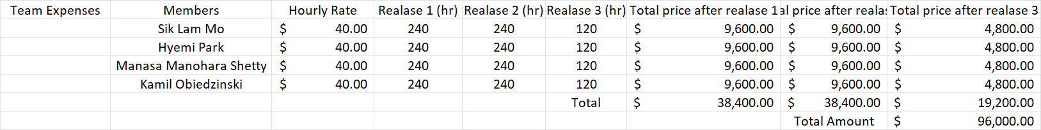

The table below shows the expected total yearly revenue with an initial 300 clinic members.



The table below shows the expected profit after considering the initial investment for the 1st year.

|  |  |  |
| --- | --- | --- |
| Total Expected Revenue | Total Expenses | Profit |
| $720,000.00 | $182,700.00 | $537,300.00 |

From our initial estimate, we can expect a $720,000.00 revenue annually. The low cost of investment makes the project a viable opportunity to establish a fast and large network. Our product and vision focus on providing a better user experience to the patient that need to make clinical appointments. As the adoption of our system spreads, the prospects of expanding to other provinces will become a new frontier of opportunity.

| START-UP COST | | | | |
| --- | --- | --- | --- | --- |
| COST ITEMS | DATE | BUDGET | MONTLY | TOTAL |
|  | | | | |
| ADMINISTRATIVE/GENERAL |  |  |  |  |
| Licenses/Registration |  |  |  |  |
| Permits |  | $300 |  | $300 |
| Insurance |  | $200 | 12 | $2,400 |
| Legal |  |  |  |  |
| Business Consultant |  |  |  |  |
| City Tax |  | $7400 |  | $7400 |
| Software (General) |  |  |  |  |
| TOTAL |  |  |  | $10,100 |
| LOCATION/OFFICE |  |  |  |  |
| Space Rental/Lease |  | $3000 | 12 | $36,000 |
| Utility Costs |  | $150 | 12 | $1,800 |
| Telephone Set up & Annual Cost |  | $50 | 12 | $600 |
| Furniture |  | $2,400 |  | $2,400 |
| Laptops for Team |  | $2,000 |  | $8,000 |
| Hardware |  |  |  |  |
| Internet |  | $200 | 12 | $2,400 |
| Installation Fees |  |  |  |  |
| TOTAL |  |  |  | $51,200 |
| Online Services |  |  |  |  |
| Logo, branding, website |  | $200 |  | $200 |
| Advertising/listing fees |  |  |  |  |
| Google ads |  | $1,000 | 12 | $12,000 |
| Facebook ads |  | $1,000 | 12 | $12,000 |
| Server Rent (AWS) |  | $100 | 12 | $1,200 |
| Networking events |  |  |  |  |
| TOTAL |  |  |  | $25,400 |
| LABOR EXPENSES |  |  |  |  |
| Payroll |  | $96,000 |  | 96,000 |
| Training |  |  |  |  |
| OTHER |  |  |  |  |
| TOTAL |  |  |  | 182,700.00 |
|  |  |  |  |  |
| ESTIMATED START-UP BUDGET |  |  |  | $182,700.00 |

# PROJECT PROFIT FORECASTING

The model below shows a forecasting profit of the following 12 months after the 3rd release

|  |  |  |  |  |  |  |  |  |  |  |  |  |  |
| --- | --- | --- | --- | --- | --- | --- | --- | --- | --- | --- | --- | --- | --- |
| OFFICE |  |  |  |  |  |  |  |  |  |  |  |  |  |
|  | | | | | | | | | | | | | |
| REVENUE | JAN | FEB | MAR | APR | MAY | JUN | JUL | AUG | SEP | OCT | NOV | DEC | YTD |
| Subscription Revenue | $60,000 | $60,000 | $60,000 | $60,000 | $60,000 | $60,000 | $60,000 | $60,000 | $60,000 | $60,000 | $60,000 | $60,000 | $720,000 |
| Less (Discounts, Billing Errors, Declined insurance, etc.) | ($1,000) | ($1,000) | ($1,000) | ($1,000) | ($1,000) | ($1,000) | ($1,000) | ($1,000) | ($1,000) | ($1,000) | ($1,000) | ($1,000) | ($12,000) |
| Service Revenue | $0 | $0 | $0 | $0 | $0 | $0 | $0 | $0 | $0 | $0 | $0 | $0 | $0 |
| Other Revenue | $0 | $0 | $0 | $0 | $0 | $0 | $0 | $0 | $0 | $0 | $0 | $0 | $0 |
| Net Sales | $59,000 | $59,000 | $59,000 | $59,000 | $59,000 | $59,000 | $59,000 | $59,000 | $59,000 | $59,000 | $59,000 | $59,000 | $708,000 |
| Cost of Goods Sold | $0 | $0 | $0 | $0 | $0 | $0 | $0 | $0 | $0 | $0 | $0 | $0 | $0 |
| Gross Profit | $59,000 | $59,000 | $59,000 | $59,000 | $59,000 | $59,000 | $59,000 | $59,000 | $59,000 | $59,000 | $59,000 | $59,000 | $708,000 |
|  | | | | | | | | | | | | | |
| EXPENSES | JAN | FEB | MAR | APR | MAY | JUN | JUL | AUG | SEP | OCT | NOV | DEC | YTD |
| Administrative General | $842 | $842 | $842 | $842 | $842 | $842 | $842 | $842 | $842 | $842 | $842 | $842 | $10,104 |
| Location/Office | $4,267 | $4,267 | $4,267 | $4,267 | $4,267 | $4,267 | $4,267 | $4,267 | $4,267 | $4,267 | $4,267 | $4,267 | $51,204 |
| Marketing | $2,116 | $2,116 | $2,116 | $2,116 | $2,116 | $2,116 | $2,116 | $2,116 | $2,116 | $2,116 | $2,116 | $2,116 | $25,392 |
| Labor | $8,000 | $8,000 | $8,000 | $8,000 | $8,000 | $8,000 | $8,000 | $8,000 | $8,000 | $8,000 | $8,000 | $8,000 | $96,000 |
| Other | $0 | $0 | $0 | $0 | $0 | $0 | $0 | $0 | $0 | $0 | $0 | $0 | $0 |
| Total Expenses | $15,225 | $15,225 | $15,225 | $15,225 | $15,225 | $15,225 | $15,225 | $15,225 | $15,225 | $15,225 | $15,225 | $15,225 | $182,700 |
| Income Before Taxes | $43,775 | $43,775 | $43,775 | $43,775 | $43,775 | $43,775 | $43,775 | $43,775 | $43,775 | $43,775 | $43,775 | $43,775 | $525,300 |
| Income Tax Expense | $6,566 | $6,566 | $6,566 | $6,566 | $6,566 | $6,566 | $6,566 | $6,566 | $6,566 | $6,566 | $6,566 | $6,566 | $78,792 |
|  | | | | | | | | | | | | | |
| NET INCOME | $37,209 | $37,209 | $37,209 | $37,209 | $37,209 | $37,209 | $37,209 | $37,209 | $37,209 | $37,209 | $37,209 | $37,209 | $446,508 |
|  | | | | | | | | | | | | | |

# THE PRODUCT VISION

# PRODUCT PERSONAS

|  |  |
| --- | --- |
| Mrs. Mary Lobo      ADMINISTRATION | DEMOGRAPHICS     * Working at Clinic administration department * 42 years old * Lives in Brossard * Married, has 2 kids |
| BEHAVIORS   * Buys take-away for lunch 3 times per week. * Frequently feels overwhelmed when she forgets something. * Frequently feels depressed, frustrated, and tired while communicating with patients on the phone. * Uses Online grocery shopping App and online banking App on mobile. * Uses internet to make an appointment for kid’s activities. | NEED   * *I need a system that can help the patient get information, so I don't need to pick up the phone during lunchtime.*      * *I hope the walk-in patients have the profile ready before they come to the clinic.* * *I need a system that can help me to manage the patients and doctor’s appointments more clearly and safely.* * *I don’t like seeing patients sit in the clinic waiting for a few hours and keep asking how long theyhave to wait.* |

|  |  |
| --- | --- |
| Ms. Vanessa Kirby      ADMINISTRATION | DEMOGRAPHICS     * Working at Clinic administration department * 31 years old * Works in Montreal * Single, No kids |
| BEHAVIORS   * Frequently feels frustrated and tired while using too many applications and software and communicating with patients on the phone at the same time      * Not afraid of hard work, and spending all day in the clinic * Uses smartphone to communicate with others * Uses laptop to seek information online * Uses the internet for social networks (Facebook, Instagram, LinkedIn, Twitter) * Does most of her banking online | NEED   * *I need a system that can help the patient get the information and make the appointment online, so I don't need to explain every time.* * *I wish I can have the information about a patient’s condition before they walk in so I can let the doctor know which patients require attention the most* * *I need a better and faster scheduling system that can help me manage the patient’s appointments* * *I don’t like seeing a patient sitting in the clinic wait for few hours, that makes me feel stressed.* |

|  |  |
| --- | --- |
| Mrs. Joel Lobo  A person with the hand on the head  Description automatically generated with low confidence  PATIENT | DEMOGRAPHICS:     * Retired. * 65 years old. * Lives in Montreal * Widowed. |
| BEHAVIORS     * She has a lot of health problems like diabetes, Blood Pressure, etc. So, she needs a regular check-up every month.      * sometimes she needs an emergency appointment since her health status is not stable.      * Also, she doesn’t have a family doctor.      * She always faces difficulty in booking appointments.      * She is leaving alone in Canada because her children living in another country and her husband expired a few years ago | NEED     * *Since Mrs. Joel is living alone, and she needs to go to the clinic many times, she finds difficulty in booking appointments.*      * *She wants to have an application or someone who helps her to get an appointment from home so that she need not call many times to the clinics, and she wants to avoid the long waits in the clinics.* |

|  |  |
| --- | --- |
| Dr. Joe Brown      DOCTOR | DEMOGRAPHICS     * Working as doctor in one of the private clinic * 60 years old * Lives in Montreal * A father |
| BEHAVIORS     * Likes learning new things like technology and medical breakthrough.      * Uses his time with patients efficiently to make sure helps help as many people as he can.      * Uses Google calendar and Trello when organizing family matters. | NEED   * *I wish I was able to treat more patients.*      * *With my 30 years of experience, I know that the cur appointment-making king system is one of the botnecksneck that is slowing us down.*      * *If we had a new and more dynamic appointment-making system, I believe we can be more efficient in threatening patients.*      * *If I knew a quick general reason why patients are visiting the clinic, I know I would be able to find the problem faster.* |

|  |  |
| --- | --- |
| Dr. Sara Smith    DOCTOR | DEMOGRAPHICS:     * Working as doctor in one of the private clinic * 32 years old * Lives in Montreal * Married, two kids |
| BEHAVIORS   * Takes as many steps and behaviors possible to be more environmentally friendly.      * Uses the latest and newest technologies and applications to make her life easier, efficient, and environmentally friendly.      * Uses Google calendar and Trello to organize every moment of her life.      * Uses online banking, online purchases, and online streaming for convenience and to reduce her carbon footprint.      * Book appointments through the websites. | NEED   * *I wish we can reduce the amount of paper we use at the clinic. It takes too much space and is a waste of resources.*      * *I wish we would all-digitalized to make the information about my patients easier to get and faster. Instant information is a necessity.*      * *I feel like the medical system is a decade or two behind the rest of the world.*      * *If patients are waiting for their appointments, they can be using that time to inform me of their symptoms instead of doing nothing while they wait.* |
|  |  |

# UML

## Use Case

### Online Booking

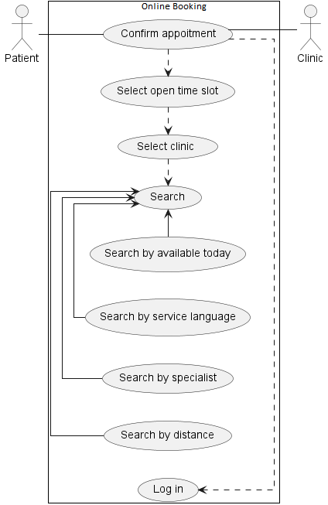

### Login

### Online Pay

### Online Scheduling

## Sequence Diagram

### Confirm Appointment

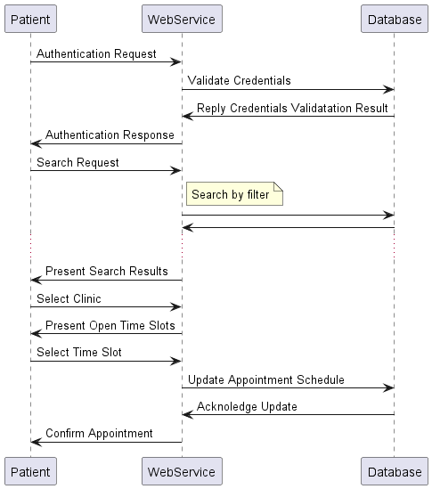

### Select Open Time Slot

### Select Clinic

### Search

### Search Today

### Search Language

### Search Specialist

### Search Nearby

### Patient Login

### Register

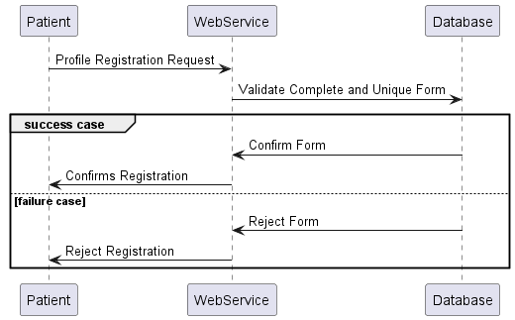

### Cancel Appointment

### Password Reset

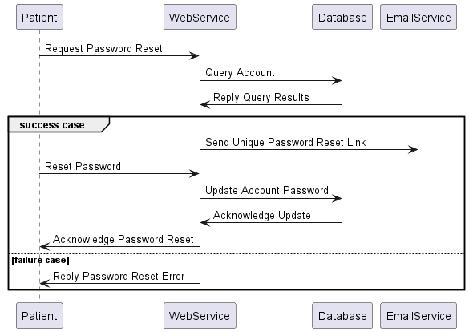

### Make Payment

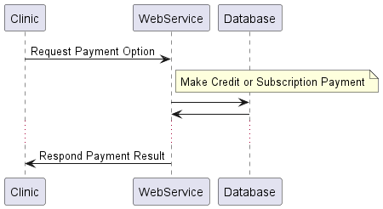

### Credit Payment

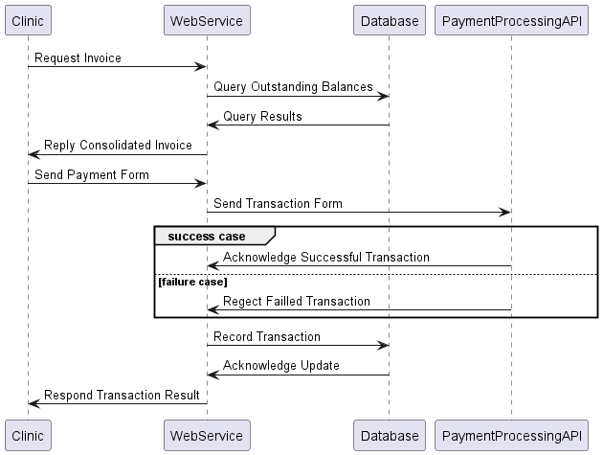

### Payment subscription

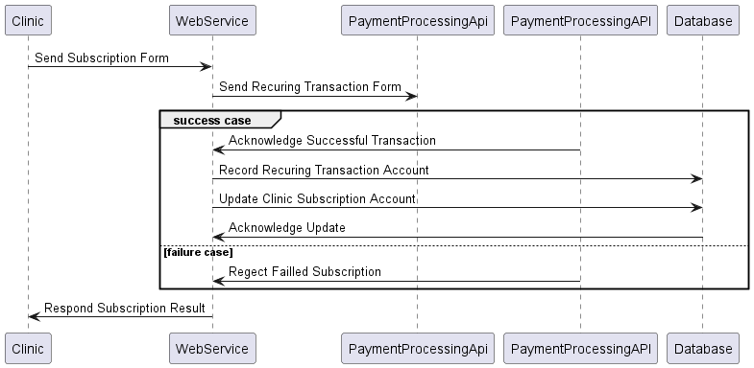

### Clinic Login

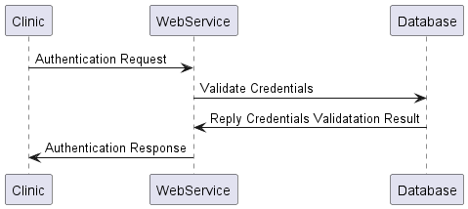

### Manage Appointment

### Cancel Appointment

### Add Appointment

### Modify Appointment

## Class Diagram

# PRODUCT ROADMAP

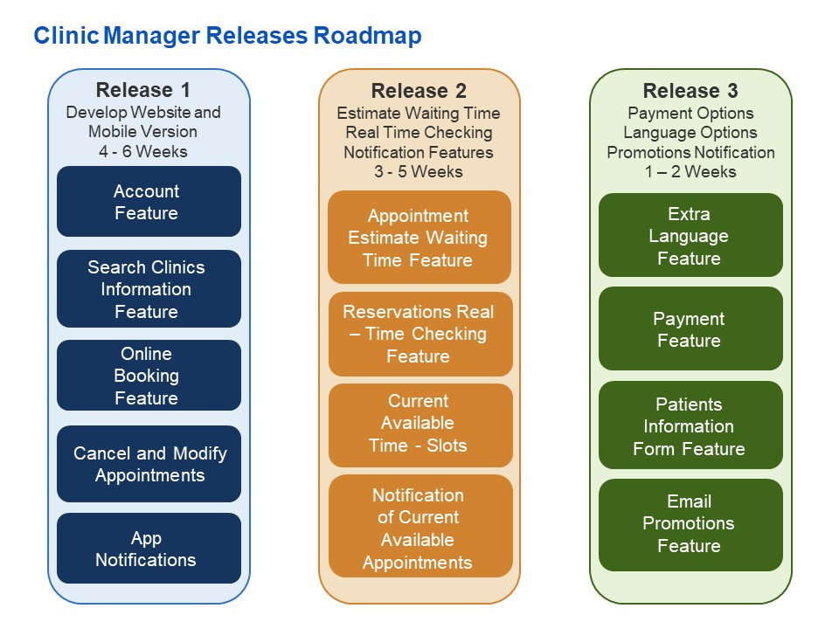

# KANBAN BOARD

## Sprint 1

|  |  |  |
| --- | --- | --- |
| TO DO | DOING | DONE |
| As a patient, I want to be able to input my postal to get clinics that are near me so that I see the clinics near me. | As a User, I want to be able to make an appointment online, so that I don’t need to wait for someone to pick up the phone | As a user(patient), I can book my appointments online so that I can save my time and energy in traveling. |
| As a user/patient, I want a list of clinics with their location information in a card format so that I can easily understand my options. | As a non-registered user(patient), when I want to confirm the appointment, I should be able to signup. | As a user(patient), I want to book appointments online so that I can save time in calling each clinic. |
| As a user/patient, I want a map that shows the clinics nearby so that I can easily situate them. | As a user(patient), I want to use the website to easily find the clinics so that it would be easy for me to search for clinics being a newcomer to Canada. | As a user (Patient) once I log in to confirm the appointment, then I want a registration form so that I can enter the information for the reason for consultation. |
| As a Doctor I want my patients to provide me with a general reason for the appointment so that I know where I should start my questioning. | As a User (Administrator), I want to have a real-time application to check our reservations, so that I don't make any mistakes between doctor and patient. | As a user, I want to be able to fill my information form online / at home, so that I don’t need to do that when I arrive to clinic |
| As a user/patient, I want to zoom in and out of the map so that I can have better understanding of the area and see other clinics as options. |  | As a User (Administrator), I want to use an online reservation system, so that I don't need to always pick up the phone. |

## Sprint 2

|  |  |  |
| --- | --- | --- |
| TO DO | DOING | DONE |
| As a patient/ user, I want to check or cancel my appointment online so that I don't need to make a phone call. | As a user (Patient), I want to know information about specialists available near me so that I can directly book the appointment online for my sickness. | As a user (Patient), I want to know whether my appointment is confirmed so that I need not try for another clinic. |
| As a User (Patient), I wish the clinic app will send me the notification so that I would not forget the doctor's appointment. | As a user(patient), I want to confirm the appointment so that I will get a message regarding the confirmation. | As a user(patient), I want to receive messages about appointments if it is cancelled by the clinic itself so that i need not go the clinic. |
|  | As a user(administrator), I want to send a auto notification when we change or cancel the appointment. | As a user(administrator), I want to get a notification when patient cancel the appointment. |
|  |  | As a user(administrator), I want to get a notification when patient change the appointment. |

## Sprint 3

|  |  |  |
| --- | --- | --- |
| TO DO | DOING | DONE |
| As a Doctor I want to know how much time I take for each of my patients so that I can analyze my workflow and find a potential weakness. | As a user/patient I want to be able to choose an option to show me clinics that have open appointments today, certain distance, and type of doctor (as filters) so that I know which clinics are my options. | As a user(patient), I want to be able to check if there is an empty spot today, so that I can make the appointment and see the doctor immediately |
| As a user(patient), I want the system should update the available appointments if any patient cancels appointments within hours so that I can book the appointments immediately |  | As a user, I want to know how many patients in front of me, so that I know when I going to leave home. |
| As a user, I want to check the waiting time, so that I know how long I need to wait. |  |  |

## Sprint 4

|  |  |  |
| --- | --- | --- |
| TO DO | DOING | DONE |
| As a user/patient, I want my appointment time to give me a more accurate estimate of the time of my appointment throughout the day so that I don’t waste my time waiting in the clinic for multiple hours. | As a user/patient, I want the list of clinics to visually tell me how booked each clinic are so that I don't have to waste my time verifying their schedule. | As a User (Administrator), I want to update the clinic schedule in real-time on the application so that I can provide the Patient with the latest information. |

## Sprint 5

|  |  |  |
| --- | --- | --- |
| TO DO | DOING | DONE |
| As a User (Patient), I want to find a clinic that speaks my language, so that I can communicate better with doctors & clinic | As a user (Patient) I want to select my preferred language .... so that I can navigate the website in a language I understand. | As a user I want to know about the different payment options available. |

## Sprint 6

|  |  |  |
| --- | --- | --- |
| TO DO | DOING | DONE |
| As a User (Administrator), I want to work as paperless as possible, so that I don’t need to print the document each time. | As a User (Doctor), I want to send prescriptions to patients through the app so that all the records & information of the patient will stay under his/her name. | As a user, I want to receive email notifications about the promotions in the clinics for different treatments |

# MOCK-UP

xvvxxcxc

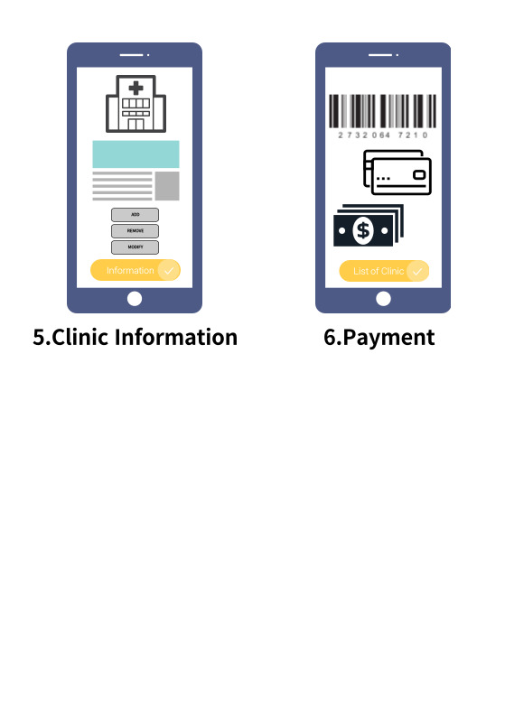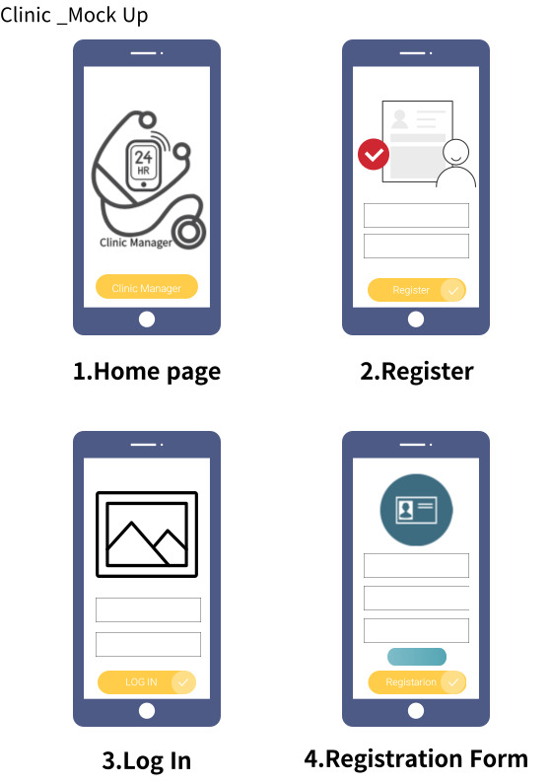

# PROJECT APPENDIX

## Team Charter

|  |  |  |  |  |
| --- | --- | --- | --- | --- |
| Member | *Hymei* | *Kamil* | *Mo* | *Manasa* |
| **MBTI** | ENFJ-A | ISFJ-T | ISFJ-T | ESFJ-T |
| **DISC** | *Steaminess* | Compliance | Compliance | Steadiness |
| **Conflict Resolution Management Style** | Collaborating  Compromising  Accommodating | Accommodating  Avoiding  Collaborating | Compromising | Accommodating  Competing |
| **Conflict Resolution Strategy** | Have stronger my own opinion | Creating a line of communication  Negotiation | Honesty | Compromising |
| **Needs &/or Expectations** | Speak up more  For Negotiation | Meet deadlines  Good communication | Reliability | Communication |
| **Boundaries** | Too negative  Too stubborn | Personal and workplace do not overlap  Not being fair | Selfish | Being dishonest  Ignore |
| **If you can say something to your teammates that would go a long way …** | I will do my best to success our project, let me know if you feel that I am doing nothing for our project. | I am positive that we can do great work if the work is divided equally and fairly and done at a reasonable pace. | Compliments, something like:  “We made some good points in the meeting today” | I will work efficiently to reach the goal |
| **Ideal Teammate** | Co-partnership  Motivated  Precise  Be cool | Hardworking  Understanding  Prepared  Flexible  No drama | Positive attitude  Energetic attitude  Unselfish  Humble  Honest | Honest  Trustworthy  Motivated  Efficient  Collaborative |
| **Ideal Team Dynamics** | Produce Harmony  Team spirit | Respectful  Confident with ideas  Shared ideas  Don't overextend the scope of the project | Share purpose  Willingness to correct mistakes | Good communication  Collaborative |

## SWOT Analysis

|  |  |  |
| --- | --- | --- |
| STRENGTHS   * Detailed – Orientated * Respectful * Collaborations * Good at seeing different perspectives | SWOT | WEAKNESSES   * Pros and cons * Missing Dominant * Difficulty managing with stress * Limited knowledge (team, medical) |
| OPPORTUNITIES   * Experience in teamwork (meet new people) * Learning new applications and workflow agile * Learn more about the medical system that has a gap * Learn from the prof’s experience | THREATS   * Not having each member heard * Time management * Shyness * Not being direct or specific |

## Communication Plan

Each Thursday after class 4 pm, we (all teammates) meet up at the cafeteria.

Option is online team meeting when needed. About the project and with the new topic from class.

Trello and group chat on teams.

On team chat will have our documentation.

## Roles & Responsibilities

Product Owner: Sik Lam Mo

Scrum Master: Manasa Manohara Shetty, Hyemi Park, Kamil Obiedzinski

Development Team: Sik Lam Mo, Manasa Manohara Shetty, Hyemi Park, Kamil Obiedzinski

## Team Charter

Every week we meet to work on the project.

Respectful of everyone’s ideas

We make sure that everyone’s idea is heard.

Everyone brings an idea.

We use pros and cons to each idea.

As a team, we make a decision (vote, get outside recommendation from 3rd party).

We follow the plans which is given by the prof.

We keep a record of each meeting. (Documentation, Trello)

When the project is done, we go eat pizza.

At the start of each meeting, we ask how everyone is feeling the state of the project.

At the start of each meeting, we have coffee or tea.

## Meeting Logs

Scrum Master Log

Log Author: <Manasa Manohara Shetty>Team/APP/Information System: < Clinic Santé>

MEETING SPECIFICS

|  |  |  |  |  |
| --- | --- | --- | --- | --- |
| Meeting # | Date | Platform | Time | Duration |
| 1 | 02/06/2022 | Face to Face | 4.00PM:4:30PM | 30 minutes |

ATTENDANCE

|  |  |  |  |  |  |
| --- | --- | --- | --- | --- | --- |
| Name | Whole Meeting | Most of the Meeting | Parts of the Meeting *-how long?* | Absent | If a team member did not attend the whole meeting, specify the reason why |
| Kamil Obiedzinski | X |  |  |  |  |
| Manasa Manohara Shetty | X |  |  |  |  |
| Hyemi Park | X |  |  |  |  |
| Sik Lam Mo | X |  |  |  |  |

DAILY SCRUM

|  |  |  |  |
| --- | --- | --- | --- |
| Name | What have I done since our last meeting | What am I doing until our next meeting | What are my impediments |
| Kamil Obiedzinski | Find articles about the problem we are trying to solve | Come up with features ideas | The workload of other classes |
| Manasa Manohara Shetty | suggested some names for our group | I will help to build the team charters | Time management |
| Hyemi Park | Brain storming about Project, especially about Initiation & Planning | Will have more Ideas for Project names. | Time management |
| Sik Lam Mo | Discuss the direction of our project | Create the basic concept of the table of content | Time management |

PROJECT STATUS

|  |  |  |  |  |  |
| --- | --- | --- | --- | --- | --- |
| Product/Project Component | Not Yet | To Do | In Progress (% of completion) | Done | We have an Issue! |
| Business Case |  |  | 10% |  |  |
| Product Vision & Box |  |  | 10% |  |  |
| Personas | X |  |  |  |  |
| User Stories Workshop (story and acceptance criteria) |  |  | 10% |  |  |
| Estimation Planning & Moscow Prioritization |  |  | 10% |  |  |
| TRELLO – final setup |  | X |  |  |  |
| Product Roadmap |  | X |  |  |  |
| Sprint Planning (Potential breakdown of user stories into requirements and/or tasks) |  | X |  |  |  |
| Design Mock-up (optional) |  | X |  |  |  |
| Team Charter |  | X |  |  |  |
| Meeting Logs |  | X |  |  |  |
| Burndown Chart | X |  |  |  |  |
| Retrospective | X |  |  |  |  |
| Report (Outlining/Writing/Editing) | X |  |  |  |  |
| Building Presentation Slides | X |  |  |  |  |
| Dry Runs (practice presentation) | X |  |  |  |  |

IMPEDIMENTS

In beginning we had an issue with business case. We had a confusion whether we have to go with Private or Government. We settled on going with private after exploring the possibilities

Scrum Master Log

Log Author: <Manasa Manohara Shetty>Team/APP/Information System: < Clinic Santé>

MEETING SPECIFICS

|  |  |  |  |  |
| --- | --- | --- | --- | --- |
| Meeting # | Date | Platform | Time | Duration |
| 2 | 09/06/2022 | Face to Face | 12:00PM-2:00PM | 2 hours |

ATTENDANCE

|  |  |  |  |  |  |
| --- | --- | --- | --- | --- | --- |
| Name | Whole Meeting | Most of the Meeting | Parts of the Meeting *-how long?* | Absent | If a team member did not attend the whole meeting, specify the reason why |
| Kamil Obiedzinski | X |  |  |  |  |
| Manasa Manohara Shetty | X |  |  |  |  |
| Hyemi Park | X |  |  |  |  |
| Sik Lam Mo | X |  |  |  |  |

DAILY SCRUM

|  |  |  |  |
| --- | --- | --- | --- |
| Name | What have I done since our last meeting | What am I doing until our next meeting | What are my impediments |
| Kamil Obiedzinski | Found articles about the problem | Creation of product vision box and rough mock-up. | Time management |
| Manasa Manohara Shetty | searching names for the project | Creation of product vision box and rough mock-up. | Time management |
| Hyemi Park | I was thinking more about our project name and research clinic system in Quebec | Make a Logo for our Project | Do not have much time |
| Sik Lam Mo | Research of business plan | Research of the marketing of clinic APP in Quebec or Canada | Time management |

PROJECT STATUS

|  |  |  |  |  |  |
| --- | --- | --- | --- | --- | --- |
| Product/Project Component | Not Yet | To Do | In Progress (% of completion) | Done | We have an Issue! |
| Business Case |  |  | 20% |  |  |
| Product Vision & Box |  |  | 20% |  |  |
| Personas | X |  |  |  |  |
| User Stories Workshop (story and acceptance criteria) |  |  | 20% |  |  |
| Estimation Planning & Moscow Prioritization |  |  | 10% |  |  |
| TRELLO – final setup |  |  | 5% |  |  |
| Product Roadmap |  |  | 5% |  |  |
| Sprint Planning (Potential breakdown of user stories into requirements and/or tasks) |  | X |  |  |  |
| Design Mock-up (optional) |  | X |  |  |  |
| Team Charter |  |  | 80% |  |  |
| Meeting Logs |  |  | 10% |  |  |
| Burndown Chart | X |  |  |  |  |
| Retrospective | X |  |  |  |  |
| Report (Outlining/Writing/Editing) | X |  |  |  |  |
| Building Presentation Slides | X |  |  |  |  |
| Dry Runs (practice presentation) | X |  |  |  |  |

IMPEDIMENTS

We had problem with the time management. Still we had an issue with business case. We settled on going with private after exploring the possibilities

Scrum Master Log

Log Author: <Manasa Manohara Shetty>Team/APP/Information System: < Clinic Santé>

MEETING SPECIFICS

|  |  |  |  |  |
| --- | --- | --- | --- | --- |
| Meeting # | Date | Platform | Time | Duration |
| 3 | 17/06/2022 | Face to Face | 11:30PM-12:30PM | 1 hour |

ATTENDANCE

|  |  |  |  |  |  |
| --- | --- | --- | --- | --- | --- |
| Name | Whole Meeting | Most of the Meeting | Parts of the Meeting *-how long?* | Absent | If a team member did not attend the whole meeting, specify the reason why |
| Kamil Obiedzinski | X |  |  |  |  |
| Manasa Manohara Shetty | X |  |  |  |  |
| Hyemi Park | X |  |  |  |  |
| Sik Lam Mo | X |  |  |  |  |

DAILY SCRUM

|  |  |  |  |
| --- | --- | --- | --- |
| Name | What have I done since our last meeting | What am I doing until our next meeting | What are my impediments |
| Kamil Obiedzinski | Created product vision box(rough) | Creating personas (two each) | Time management |
| Manasa Manohara Shetty | Created product vision box | Creating Personas (two each) | Time management |
| Hyemi Park | Created product vision box | Logo and poster creation(digital) | Time management |
| Sik Lam Mo | Created product vision box | Creating personas (two each) | Time management |

PROJECT STATUS

|  |  |  |  |  |  |
| --- | --- | --- | --- | --- | --- |
| Product/Project Component | Not Yet | To Do | In Progress (% of completion) | Done | We have an Issue! |
| Business Case |  |  | 20% |  |  |
| Product Vision & Box |  |  | 20% |  |  |
| Personas |  |  | 10% |  |  |
| User Stories Workshop (story and acceptance criteria) |  |  | 20% |  |  |
| Estimation Planning & Moscow Prioritization |  |  | 10% |  |  |
| TRELLO – final setup |  |  | 5% |  |  |
| Product Roadmap |  |  | 5% |  |  |
| Sprint Planning (Potential breakdown of user stories into requirements and/or tasks) |  |  | 5% |  |  |
| Design Mock-up (optional) |  |  | 10% |  |  |
| Team Charter |  |  | 80% |  |  |
| Meeting Logs |  |  | 20% |  |  |
| Burndown Chart | X |  |  |  |  |
| Retrospective | X |  |  |  |  |
| Report (Outlining/Writing/Editing) | X |  |  |  |  |
| Building Presentation Slides | X |  |  |  |  |
| Dry Runs (practice presentation) | X |  |  |  |  |

IMPEDIMENTS

We had a plan to work on many personas. Because of the time limit we were able to six personas. But still we managed with the time.

Scrum Master Log

Log Author: <Manasa Manohara Shetty>  
Team/APP/Information System: < Clinic Santé>

MEETING SPECIFICS

|  |  |  |  |  |
| --- | --- | --- | --- | --- |
| Meeting # | Date | Platform | Time | Duration |
| 4 | 25/06/2022 | Microsoft Teams | 10:00AM-10:35AM | 35 minutes |

ATTENDANCE

|  |  |  |  |  |  |
| --- | --- | --- | --- | --- | --- |
| Name | Whole Meeting | Most of the Meeting | Parts of the Meeting *-how long?* | Absent | If a team member did not attend the whole meeting, specify the reason why |
| Kamil Obiedzinski | X |  |  |  |  |
| Manasa Manohara Shetty | X |  |  |  |  |
| Hyemi Park | X |  |  |  |  |
| Sik Lam Mo | X |  |  |  |  |

DAILY SCRUM

|  |  |  |  |
| --- | --- | --- | --- |
| Name | What have I done since our last meeting | What am I doing until our next meeting | What are my impediments |
| Kamil Obiedzinski | Created 2 personas.  Created user stories and Acceptance criteria | Finalize the user stories and acceptance criteria | Time-Management |
| Manasa Manohara Shetty | Created 2 personas.  Created user stories and Acceptance criteria | Finalize the user stories and acceptance criteria. | Time-Management |
| Hyemi Park | Created product vision box and poster(digital)  Created user stories and acceptance criteria | Finalize the user stories and acceptance criteria.  Finalize Logo and poster creation(digital) | Time-Management |
| Sik Lam Mo | Created 2 personas.  Created user stories and Acceptance criteria | Finalize the user stories and acceptance criteria. | Time-Management |

PROJECT STATUS

|  |  |  |  |  |  |
| --- | --- | --- | --- | --- | --- |
| Product/Project Component | Not Yet | To Do | In Progress (% of completion) | Done | We have an Issue! |
| Business Case |  |  | 40% |  |  |
| Product Vision & Box |  |  | 70% |  |  |
| Personas |  |  | 80% |  |  |
| User Stories Workshop (story and acceptance criteria) |  |  | 80% |  |  |
| Estimation Planning & Moscow Prioritization |  |  | 10% |  |  |
| TRELLO – final setup |  |  | 30% |  |  |
| Product Roadmap |  |  | 10% |  |  |
| Sprint Planning (Potential breakdown of user stories into requirements and/or tasks) |  |  | 5% |  |  |
| Design Mock-up (optional) |  |  | 10% |  |  |
| Team Charter |  |  | 80% |  |  |
| Meeting Logs |  |  | 30% |  |  |
| Burndown Chart | X |  |  |  |  |
| Retrospective | X |  |  |  |  |
| Report (Outlining/Writing/Editing) | X |  |  |  |  |
| Building Presentation Slides | X |  |  |  |  |
| Dry Runs (practice presentation) | X |  |  |  |  |

IMPEDIMENTS

We were not clear about the correct format of the user stories and number of user stories. Then we settled on finalizing user stories in the correct format.

Scrum Master Log

Log Author: <Kamil Obiedzinski>Team/APP/Information System: < Clinic Santé>

MEETING SPECIFICS

|  |  |  |  |  |
| --- | --- | --- | --- | --- |
| Meeting # | Date | Platform | Time | Duration |
| 5 | 06-30-2022 | Online team | 2:00pm – 2:40pm | 40 minutes |

ATTENDANCE

|  |  |  |  |  |  |
| --- | --- | --- | --- | --- | --- |
| Name | Whole Meeting | Most of the Meeting | Parts of the Meeting *-how long?* | Absent | If a team member did not attend the whole meeting, specify the reason why |
| Kamil Obiedzinski | x |  |  |  |  |
| Manasa Manohara Shetty | x |  |  |  |  |
| Sik Lam Mo | x |  |  |  |  |
| Hyemi Park | x |  |  |  |  |

DAILY SCRUM

|  |  |  |  |
| --- | --- | --- | --- |
| Name | What have I done since our last meeting | What am I doing until our next meeting | What are my impediments |
| Kamil Obiedzinski | Rework on created user stories and acceptance criteria | Finalize acceptance criteria  Rework draft of business case | Time-Management  Homework from other classes |
| Manasa Manohara Shetty | Rework on created user stories and acceptance criteria | Finalize acceptance criteria  Finalize persona | Time-Management  Homework from other classes |
| Hyemi Park | Rework on created user stories and acceptance criteria | Finalize acceptance criteria | Time-Management  Homework from other classes |
| Sik Lam Mo | Rework on created user stories and acceptance criteria | Finalize acceptance criteria | Time-Management  Homework from other classes |

PROJECT STATUS

|  |  |  |  |  |  |
| --- | --- | --- | --- | --- | --- |
| Product/Project Component | Not Yet | To Do | In Progress (% of completion) | Done | We have an Issue! |
| Business Case |  |  | 50% |  |  |
| Product Vision & Box |  |  | 70% |  |  |
| Personas |  |  | 90% |  |  |
| User Stories Workshop (story and acceptance criteria) |  |  | 90% |  |  |
| Estimation Planning & Moscow Prioritization |  |  | 10% |  |  |
| TRELLO – final setup |  |  | 30% |  |  |
| Product Roadmap |  |  | 10% |  |  |
| Sprint Planning (Potential breakdown of user stories into requirements and/or tasks) |  |  | 30% |  |  |
| Design Mock-up (optional) |  |  | 10% |  |  |
| Team Charter |  |  | 90% |  |  |
| Meeting Logs |  |  | 40% |  |  |
| Burndown Chart | X |  |  |  |  |
| Retrospective |  | X |  |  |  |
| Report (Outlining/Writing/Editing) |  | X |  |  |  |
| Building Presentation Slides | X |  |  |  |  |
| Dry Runs (practice presentation) | X |  |  |  |  |

IMPEDIMENTS

We had difficulty with visualizing the product with all it features. However, working with the users’ stories and acceptance criteria, the products has become a more concrete idea. The features are not just ideas but are now clear features.

Scrum Master Log

Log Author: <Kamil Obiedzinski >  
Team/APP/Information System: < Clinic Santé>

MEETING SPECIFICS

|  |  |  |  |  |
| --- | --- | --- | --- | --- |
| Meeting # | Date | Platform | Time | Duration |
| 6 | 07-07-2022 | In person | 12:58pm - 2:00pm | 1 hour |

ATTENDANCE

|  |  |  |  |  |  |
| --- | --- | --- | --- | --- | --- |
| Name | Whole Meeting | Most of the Meeting | Parts of the Meeting *-how long?* | Absent | If a team member did not attend the whole meeting, specify the reason why |
| Kamil Obiedzinski | x |  |  |  |  |
| Manasa Manohara Shetty | x |  |  |  |  |
| Sik Lam Mo | x |  |  |  |  |
| Hyemi Park | x |  |  |  |  |

DAILY SCRUM

|  |  |  |  |
| --- | --- | --- | --- |
| Name | What have I done since our last meeting | What am I doing until our next meeting | What are my impediments |
| Kamil Obiedzinski | Rework on Created user stories and Acceptance criteria  Points, and Moscow | Work on final document | Time-Management  Homework from other classes  Studying for finals |
| Manasa Manohara Shetty | Rework on Created user stories and Acceptance criteria  Points, and Moscow | Trello | Time-Management  Homework from other classes  Studying for finals |
| Hyemi Park | Rework on Created user stories and Acceptance criteria  Points, and Moscow | Vison box, mockup | Time-Management  Homework from other classes  Studying for finals |
| Sik Lam Mo | Rework on Created user stories and Acceptance criteria  Points, and Moscow | Extra user stories, roadmap | Time-Management  Homework from other classes  Studying for finals |

PROJECT STATUS

|  |  |  |  |  |  |
| --- | --- | --- | --- | --- | --- |
| Product/Project Component | Not Yet | To Do | In Progress (% of completion) | Done | We have an Issue! |
| Business Case |  |  | 50% |  |  |
| Product Vision & Box |  |  | 80% |  |  |
| Personas |  |  | 90% |  |  |
| User Stories Workshop (story and acceptance criteria) |  |  | 90% |  |  |
| Estimation Planning & Moscow Prioritization |  |  | 90% |  |  |
| TRELLO – final setup |  |  | 40% |  |  |
| Product Roadmap |  |  | 30% |  |  |
| Sprint Planning (Potential breakdown of user stories into requirements and/or tasks) |  |  | 30% |  |  |
| Design Mock-up (optional) |  |  | 10% |  |  |
| Team Charter |  |  | 90% |  |  |
| Meeting Logs |  |  | 50% |  |  |
| Burndown Chart | X |  |  |  |  |
| Retrospective |  | X |  |  |  |
| Report (Outlining/Writing/Editing) |  | X |  |  |  |
| Building Presentation Slides | X |  |  |  |  |
| Dry Runs (practice presentation) | X |  |  |  |  |

IMPEDIMENTS

We had difficulty with doing the workshops because one of our teammates was not a school. However, we used teams and video calling to allows us to work on the workshops. It was not ideal, but we got some work done.

Scrum Master Log

Log Author: < Sik Lam Mo >Team/APP/Information System: < Clinic Santé>

MEETING SPECIFICS

|  |  |  |  |  |
| --- | --- | --- | --- | --- |
| Meeting # | Date | Platform | Time | Duration |
| 7 | 07-14-2022 | Online Team | 12:00pm – 12:55pm | 55 minutes |

ATTENDANCE

|  |  |  |  |  |  |
| --- | --- | --- | --- | --- | --- |
| Name | Whole Meeting | Most of the Meeting | Parts of the Meeting *-how long?* | Absent | If a team member did not attend the whole meeting, specify the reason why |
| Kamil Obiedzinski | x |  |  |  |  |
| Manasa Manohara Shetty | x |  |  |  |  |
| Sik Lam Mo | x |  |  |  |  |
| Hyemi Park | x |  |  |  |  |

DAILY SCRUM

|  |  |  |  |
| --- | --- | --- | --- |
| Name | What have I done since our last meeting | What am I doing until our next meeting | What are my impediments |
| Kamil Obiedzinski | Working on Business case, including the context, business need & vision and budget | Continue working on Business case, including the context, business need & vision and budget and UML | Time-Management  Homework from other classes  Studying for finals |
| Manasa Manohara Shetty | Trello board and acceptance criteria and Points | Trello board – release/sprints | Time-Management  Homework from other classes  Studying for finals |
| Hyemi Park | Working on mock-up design | Continue Working on the mock-up design | Time-Management  Homework from other classes  Studying for finals |
| Sik Lam Mo | Added few more user stories and Working on the Roadmap | Continue working on the Product roadmap | Time-Management  Homework from other classes  Studying for finals |

PROJECT STATUS

|  |  |  |  |  |  |
| --- | --- | --- | --- | --- | --- |
| Product/Project Component | Not Yet | To Do | In Progress (% of completion) | Done | We have an Issue! |
| Business Case |  |  | 70% |  |  |
| Product Vision & Box |  |  | 95% |  |  |
| Personas |  |  | 95% |  |  |
| User Stories Workshop (story and acceptance criteria) |  |  | 95% |  |  |
| Estimation Planning & Moscow Prioritization |  |  | 90% |  |  |
| TRELLO – final setup |  |  | 50% |  |  |
| Product Roadmap |  |  | 30% |  |  |
| Sprint Planning (Potential breakdown of user stories into requirements and/or tasks) |  |  | 40% |  |  |
| Design Mock-up (optional) |  |  | 75% |  |  |
| Team Charter |  |  | 90% |  |  |
| Meeting Logs |  |  | 60% |  |  |
| Burndown Chart | X |  |  |  |  |
| Retrospective |  | X |  |  |  |
| Report (Outlining/Writing/Editing) |  | X |  |  |  |
| Building Presentation Slides | X |  |  |  |  |
| Dry Runs (practice presentation) | X |  |  |  |  |

IMPEDIMENTS

We had some difficulty with the direction of some of the content, and the time of the meeting. However, we used teams and video call to do the online meeting, also had the discussion of the content and keep continuing the project

Scrum Master Log

Log Author: < Sik Lam Mo >Team/APP/Information System: < Clinic Santé>

MEETING SPECIFICS

|  |  |  |  |  |
| --- | --- | --- | --- | --- |
| Meeting # | Date | Platform | Time | Duration |
| 8 | 07-22-2022 | In person | 17:00pm – 18:00 pm | 1 hour |

ATTENDANCE

|  |  |  |  |  |  |
| --- | --- | --- | --- | --- | --- |
| Name | Whole Meeting | Most of the Meeting | Parts of the Meeting *-how long?* | Absent | If a team member did not attend the whole meeting, specify the reason why |
| Kamil Obiedzinski | x |  |  |  |  |
| Manasa Manohara Shetty | x |  |  |  |  |
| Sik Lam Mo | x |  |  |  |  |
| Hyemi Park | x |  |  |  |  |

DAILY SCRUM

|  |  |  |  |
| --- | --- | --- | --- |
| Name | What have I done since our last meeting | What am I doing until our next meeting | What are my impediments |
| Kamil Obiedzinski | Working on UML and business case | Continue working on UML and preparing on the presentation | Time-Management  Homework from other classes  Studying for finals |
| Manasa Manohara Shetty | Continue working on Trello board | Continue working on Trello board and preparing on the presentation | Time-Management  Homework from other classes  Studying for finals |
| Hyemi Park | Working on mock-up design | Continue Working on the mock-up design | Time-Management  Homework from other classes  Studying for finals |
| Sik Lam Mo | Edit on the Product release and roadmap | Continue working on the Product roadmap | Time-Management  Homework from other classes  Studying for finals |

PROJECT STATUS

|  |  |  |  |  |  |
| --- | --- | --- | --- | --- | --- |
| Product/Project Component | Not Yet | To Do | In Progress (% of completion) | Done | We have an Issue! |
| Business Case |  |  | 80% |  |  |
| Product Vision & Box |  |  | 95% |  |  |
| Personas |  |  | 95% |  |  |
| User Stories Workshop (story and acceptance criteria) |  |  | 95% |  |  |
| Estimation Planning & Moscow Prioritization |  |  | 90% |  |  |
| TRELLO – final setup |  |  | 70% |  |  |
| Product Roadmap |  |  | 65% |  |  |
| Sprint Planning (Potential breakdown of user stories into requirements and/or tasks) |  |  | 65% |  |  |
| Design Mock-up (optional) |  |  | 80% |  |  |
| Team Charter |  |  | 90% |  |  |
| Meeting Logs |  |  | 70% |  |  |
| Burndown Chart | X |  |  |  |  |
| Retrospective |  | X |  |  |  |
| Report (Outlining/Writing/Editing) |  | X |  |  |  |
| Building Presentation Slides | X |  |  |  |  |
| Dry Runs (practice presentation) | X |  |  |  |  |

IMPEDIMENTS

We had some difficulty about the time management because we have lots of assignments and exam, but we still have finished 90% of our project. we will be discussing the retrospective and the presentation and keep continuing the project.

Scrum Master Log

Log Author: < Sik Lam Mo >  
Team/APP/Information System: < Clinic Santé>

MEETING SPECIFICS

|  |  |  |  |  |
| --- | --- | --- | --- | --- |
| Meeting # | Date | Platform | Time | Duration |
| 9 | 07-29-2022 | In person | 17:00pm – 18:30pm | 90 minutes |

ATTENDANCE

|  |  |  |  |  |  |
| --- | --- | --- | --- | --- | --- |
| Name | Whole Meeting | Most of the Meeting | Parts of the Meeting *-how long?* | Absent | If a team member did not attend the whole meeting, specify the reason why |
| Kamil Obiedzinski | x |  |  |  |  |
| Manasa Manohara Shetty | x |  |  |  |  |
| Sik Lam Mo | x |  |  |  |  |
| Hyemi Park | x |  |  |  |  |

DAILY SCRUM

|  |  |  |  |
| --- | --- | --- | --- |
| Name | What have I done since our last meeting | What am I doing until our next meeting | What are my impediments |
| Kamil Obiedzinski | Finalize the UML and merge all the scrum report into one document.  Working on retrospective | working on content of the presentation and verify that all the documents are correct | Time-Management  Final exam and assignment from other classes  Communication problem |
| Manasa Manohara Shetty | Finalize the Kanban board and merge in one document  Working on retrospective | working on content of the presentation and PowerPoint | Time-Management  Final exam and assignment from other classes  Communication problem |
| Hyemi Park | finalize the final mock-up design  Working on retrospective | working on content of the presentation and PowerPoint | Time-Management  Final exam and assignment from other classes  Communication problem |
| Sik Lam Mo | finalize the Product release and roadmap. Working on retrospective | working on content of the presentation and PowerPoint  merge and arrange the final document | Time-Management  Final exam and assignment from other classes  Communication problem |

PROJECT STATUS

|  |  |  |  |  |  |
| --- | --- | --- | --- | --- | --- |
| Product/Project Component | Not Yet | To Do | In Progress (% of completion) | Done | We have an Issue! |
| Business Case |  |  | 100% |  |  |
| Product Vision & Box |  |  | 100% |  |  |
| Personas |  |  | 100% |  |  |
| User Stories Workshop (story and acceptance criteria) |  |  | 100% |  |  |
| Estimation Planning & Moscow Prioritization |  |  | 100% |  |  |
| TRELLO – final setup |  |  | 100% |  |  |
| Product Roadmap |  |  | 100% |  |  |
| Sprint Planning (Potential breakdown of user stories into requirements and/or tasks) |  |  | 100% |  |  |
| Design Mock-up (optional) |  |  | 100% |  |  |
| Team Charter |  |  | 100% |  |  |
| Meeting Logs |  |  | 90% |  |  |
| Burndown Chart | X |  |  |  |  |
| Retrospective |  |  | 50% |  |  |
| Report (Outlining/Writing/Editing) |  |  | 70% |  |  |
| Building Presentation Slides |  |  | 10% |  |  |
| Dry Runs (practice presentation) |  | X |  |  |  |

IMPEDIMENTS

We had some difficulty on communication about the content of the presentation. Because of the stress of the exam and assignments that from the other class, so our emotion is unstable that cause us a fight/argument during the class. After we cool down, we are back to our project and have a very good discussion about the content of the presentation.

## Retrospective

|  |  |  |  |
| --- | --- | --- | --- |
| Name | Liked | Learned | Lacked |
| Manasa Manohara Shetty | -Team work  -Coordination from the team members  -Agile planning | -Support between team members to achieve the goal  -Try to finish the tasks on time  -Agile planning  -scrum master roles  -sprint planning ideas  -Trello board | -Time management  -Communication |
| Kamil Obiedzinski | - Positive Attitude  - Interesting Ideas  - Brain Storming  - Communication | - Letting others have control  - Manage the group  - Adapting to evolving workflow  - Learned basics of Plant Text UML | - Time  - Confidants  - Organization of ideas  - Fast Feed Back |
| Heymi Park | - Good Teamwork  - To share the Ideas & discuss  - Follow the work steps  - Visualizing design work | -Harmonized with Team member  - Agile Process  - New work tools  - Conflict Control | - Time management.  - Conflict management  - Finish work on time, in advance  - Conversation skills |
| Sik Lam Mo | - Everything in order  - Good Collaboration  - Good discussion on every meeting  - Finish task on time | Understanding of agile process, better use of Kanban board, user story, acceptance criteria and scrum | - Time management  - Communication  - Fixability |